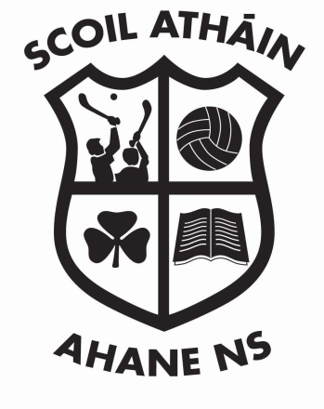
Ahane National School,
Laught,
Lisnagry,
Co. Limerick.

Tel: +353 (0) 61 335 101
Email: office@ahanenationalschool.ie
Roll number: 16508 C

Principal: Siobhán Kennedy
Deputy Principal: Grace Ryan

One to One Teaching
October 2018

One to one teaching is often seen as the best way for a pupil to improve and to achieve his/her targets as set out in the Student Support File. Once it has been decided that one to one teaching is in the best interest of the pupil consent will be sought from the parent/guardian in writing. Every effort will be made to ensure that this teaching will take place in an open environment ie teacher and pupil will be visible through a glass panelled door and/or the door will be slightly ajar. The need for one to one teaching to continue will form part of the Student Support File review with the parent/guardian.

Having read the above I give permission for _____________________ to attend one to one teaching with Ahane NS teaching staff

Signed: _______________________________________________
Date: _________________________________

This One to One Teaching Procedure was ratified by the Board of Management at a meeting on

_______________________.

_______________________ _____________________________.
Principal Chairperson

Version Control
One to One Teaching. | Date Approved |  | Review date

